**Lab#1**

* Question#1

|  |  |
| --- | --- |
| User Action | System Action |
| User types in PIN into main screen | System checks validity of PIN and presents options to user on another screen |
| User selects withdraw money | System will show him with list of all options. These options corresponding to a predefined amount ex: 50, 100, 1000, 200 ..etc |
| User selects specific amount to withdraw | System will check his balance and provide him with the amount after deducting the amount from his balance. |

* Question#2

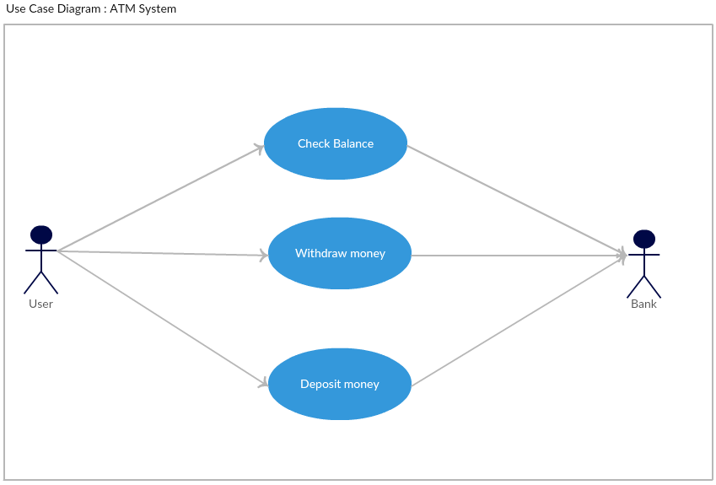

* Question#3

Project Management Tracking System

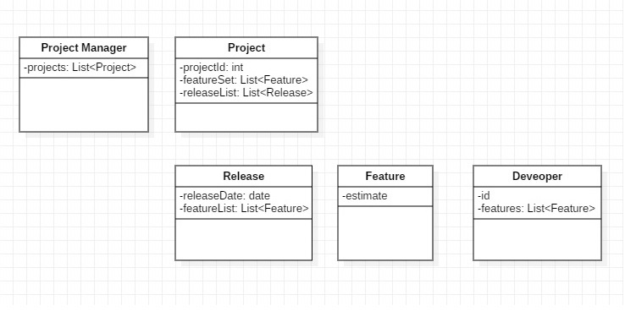

* Question#4

Properties Management System

